Stage 1 Report
- Achieved Goals

- The correctness and integrity of instructions : PASS
- The instructions coming into and out of the IFU are all similar, except for the mismatch caused by the branch instructions, which is due to the isolation of the IFU from the core.

- Timing : PASS
- No assertion error detected during simulation, all the properties are covered.

- Word-aligned Fetching : PASS
- The addresses increase by 4-byte steps, except where a branch occurs.

- Feedthrough Path : PASS
- When the prefetch FIFO is empty, the instruction only takes 1 cycle to reach
the output of the IFU.

- FIFO Limit : PASS
- When the prefetch FIFO is full, no more instr_req signal is asserted.

- Critical Testbench Bugs and Solutions

- The “Zombie PC” (Achitectural Wakeup Trap)
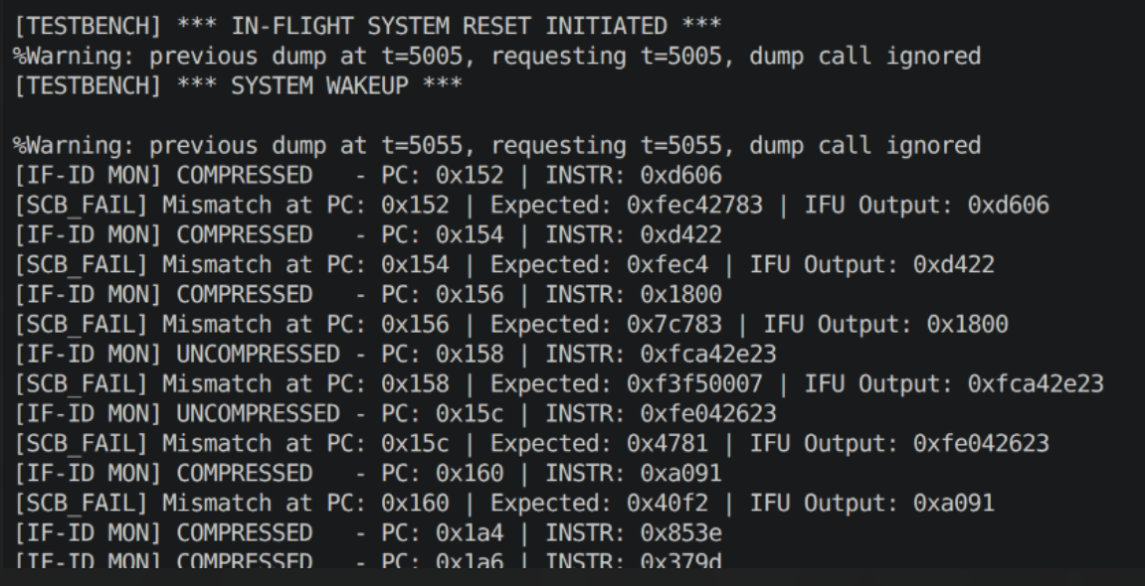
- Symptom : After the mid-flight reset, the IFU wakes up and continues fetching from the address in which it has been interrupted (e.g. 0x152) instead of the boot address (i.e. 0x100080).

- Root Cause : This bug appears due to the lack of a hard reset pin connected to the actual hardware Program Counter.

- Explanation : In real hardware silicon, the Program Counter does not have a physical reset pin connected to it (to save the silicon space). Because of this shortage, the PC will keep the old address until the Instruction Decode stage overwrite it using the pc_set_i signal.

- Solution : We will add (and connect) the pc_set_i pin in the top-level module. After that, we will mimic the behavior of the ID stage by driving the pc_set_i = 1 for one cycle after the IFU wakes up.

- The Phantom JAL (OBI Protocol Request Abort)
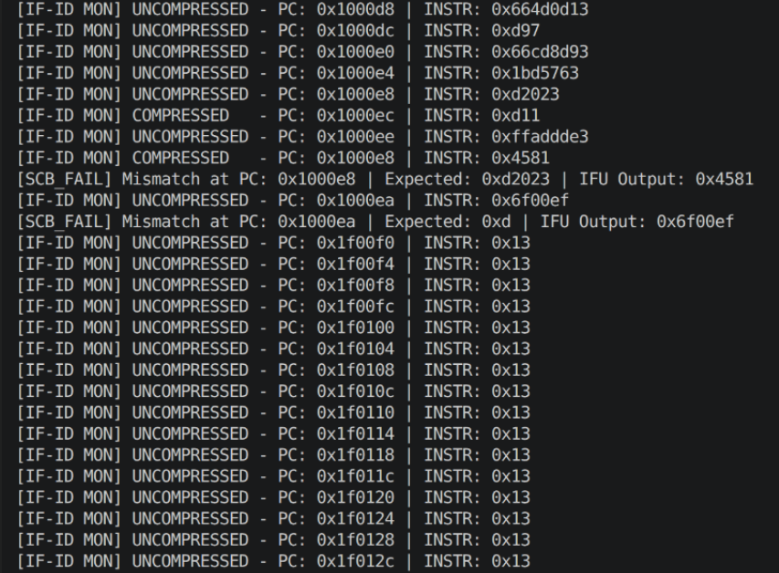
- Symptom : The IFU takes a valid backward branch, but immediately jumps into unmapped memory and crashes.

- Root Cause : This problem exists because the Memory Driver is missing a logic that supports the OBI request cancellation.

- Explanation : When the IFU takes the branch, it flushes the pipeline and set the instr_req_o to 0 to cancel the prefetch. However, due to the lack of the request abort logic, the driver ignores the change and keeps returning the stale prefetch data, which leads to the IFU mistakenly accepts the wrong data.

- Solution : We will add the request abort logic to ensure the prefetch is cancel when the IFU drops the instr_req_o signal.

- The Combinational-Flush Race Condition
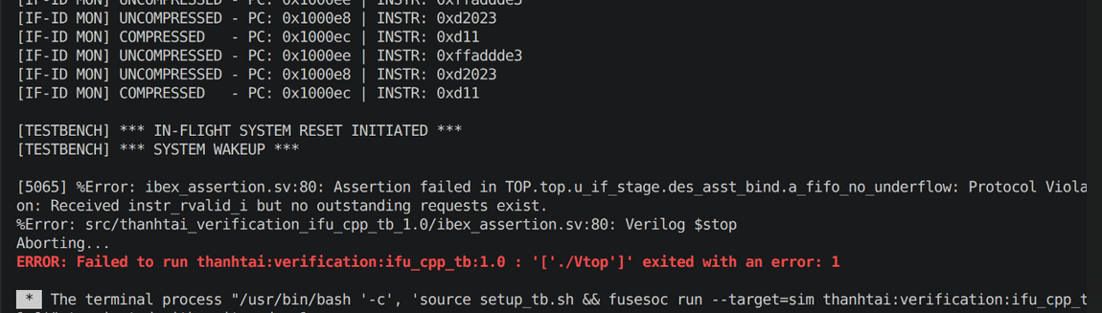
- Symptom : Encounters the assertion failure “Protocol Violation: Received instr_rvalid_i but no outstanding requests exist” depending on the random seed.

- Root Cause : This error occurs due to the assert of instr_gnt_i = 1 and instr_rvalid_i = 1 on the exact same cycle.

- Explanation : The Memory Driver asserts a new grant (instr_gnt_i = 1) on the exact same cycle it returned a valid data (instr_rvalid_i = 1). This simultaneous assert will not pose any threat unless the instruction is a branch. If the valid data is a branch instruction, the IFU would combinationally flush and drop its request line in that same cycle. However, since the instr_gnt_i has already been sent, the protocol assertion is violated.

- Solution : We will use a rvalid_fired_this_cycle flag to force the Driver to wait one full cycle after delivering data before being allowed to grant a new request, giving the hardware time to safely evaluate branch flushes.

- The Off-By-One Data Shift
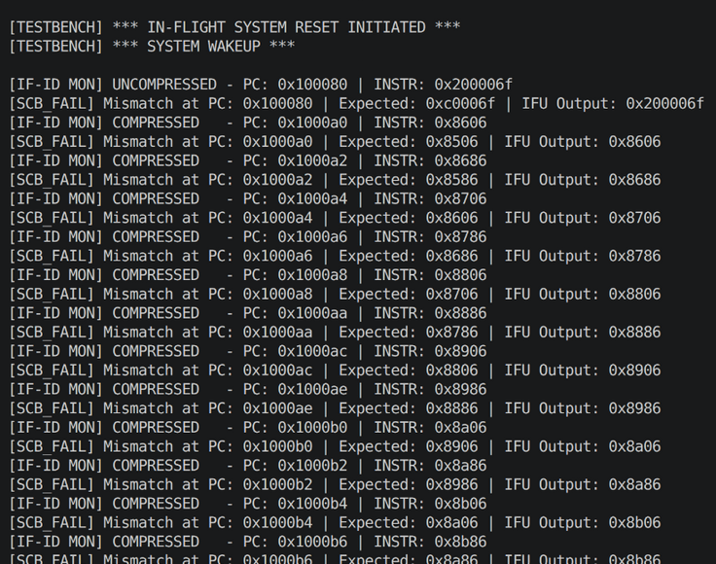
- Symptom : After the mid-flight reset, the IFU Outputs are trailing exactly one address behind (i.e. Each instruction is duplicated for two consecutive PC).

- Root Cause : This error is caused because we attempted to skip the comp->run() during the pipeline flush (i.e. The duration when pc_set_i = 1).

- Explanation : In Verilator, if we failed to drive a pin (i.e. if we skip the comp->run() execution during the flush), it will act as a hardware latch holding the old data. This in turns caused the driver to queue a transient "Zombie PC" request (i.e. It will send the instruction of the address before the mid-flight reset)..

- Solution : We will not skip the comp->run(). Instead, we will force the testbench to flush (comp->reset()) if the cool down is still in effect (i.e. tb_cooldown > 0)

- Testbench Optimization Features

- Polymorphic Component Architecture

- Benefit : Transitioned from a monolithic script to a modular, Object-Oriented framework. By deriving all elements like the Scoreboard, Monitor, and Driver from a single TbComponent parent class, we established standardized run() and reset() functional interfaces across the environment.

- Benefit : This architecture separates the core simulation loop from specific element logic. Utilizing a std::vector<TbComponent*> tb_env container enables the environment to trigger execution or system flushes across the testbench via a singular, scalable for iteration.

- Mid-Flight System Stress Testing

- Feature : Developed a mechanism to trigger an asynchronous hardware reset (rst_ni = 0) during active memory cycles to simulate mid-operation system failure.

- Benefit : Demonstrates the capacity for environment elements and RTL to purge flight queues, stabilize after abrupt memory termination, and execute a fresh boot sequence devoid of hangs or bus errors.

- Deterministic Constrained Random Verification (CRV)

- Feature : Substituted the memory driver's std::random_device with the contextp->randSeed() provided by Verilator to eliminate unmanaged hardware entropy.

- Benefit : By anchoring the pseudo-random variance (delays ranging from 0 to 5 cycles for grants and validations) to a singular master seed, the environment ensures full visibility into system failures. This approach provides 100% reproducibility, allowing any specific timing-related bug to be perfectly reconstructed for isolated analysis and debugging.

- Automated Python Regression Suite

- Feature : Implemented a streamlined Python-based regression harness (run_regression.py) designed to encapsulate the fusesoc build environment.

- Benefit : Enables the testbench to conduct rapid-fire simulation batches utilizing diverse randomization seeds. This tool performs automated terminal log parsing and Scoreboard metric aggregation, ensuring that any seed inducing an edge-case violation is captured alongside its specific reproduction command for immediate debugging.

